**Industrial Internship Report on**

**” Online Learning Management System”**

**Prepared by**

**[Abhishek Girishchandra Tiwari]**

|  |
| --- |
| *Executive Summary* |
| This report provides details of the Industrial Internship provided by upskill Campus and The IoT Academy in collaboration with Industrial Partner UniConverge Technologies Pvt Ltd (UCT).  This internship was focused on a project/problem statement provided by UCT. We had to finish the project including the report in 6 weeks’ time.  My project was (Online Learning Management System)  This internship gave me a very good opportunity to get exposure to Industrial problems and design/implement solution for that. It was an overall great experience to have this internship. |

**TABLE OF CONTENTS**

1 Preface 3

2 Introduction 4

2.1 About UniConverge Technologies Pvt Ltd 4

2.2 About upskill Campus 8

2.3 Objective 9

2.4 Reference 9

2.5 Glossary 10

3 Problem Statement 11

4 Existing and Proposed solution 12

5 Proposed Design/ Model 13

5.1 High Level Diagram (if applicable) 13

5.2 Low Level Diagram (if applicable) 13

5.3 Interfaces (if applicable) 13

6 Performance Test 14

6.1 Test Plan/ Test Cases 14

6.2 Test Procedure 14

6.3 Performance Outcome 14

7 My learnings 15

8 Future work scope 16

# Preface

The six-week internship focused on developing an Online Learning Management System and hosting it on Heroku. The need for relevant internships in career development cannot be overstated, as they provide practical experience and industry exposure. My project involved creating a system for managing student and admin interactions, course selections, and online chat functionalities. The program was well-structured, offering a balanced mix of learning and practical application.

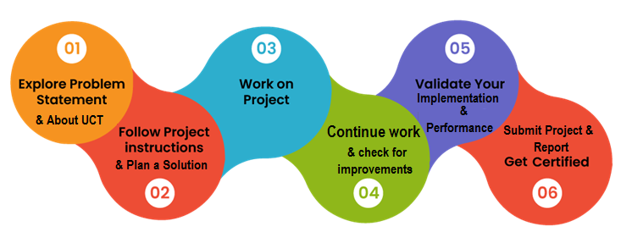

During this six-week internship, I learned the importance of effective project management and teamwork. I gained insights into handling real-world challenges, which enhanced my problem-solving skills and adaptability. This internship also taught me the value of consistent communication and collaboration with peers and mentors, which is crucial for professional growth. Overall, this experience significantly boosted my confidence in tackling complex projects and prepared me well for future career endeavors.

To my juniors and peers, I encourage you to seize internship opportunities as they provide practical industry experience and enhance your skill set. Embrace challenges, seek feedback, and continuously learn. Your dedication and effort will pave the way for a successful career.

# Introduction

## About UniConverge Technologies Pvt Ltd

A company established in 2013 and working in Digital Transformation domain and providing Industrial solutions with prime focus on sustainability and RoI.

For developing its products and solutions it is leveraging various**Cutting Edge Technologies e.g. Internet of Things (IoT), Cyber Security, Cloud computing (AWS, Azure), Machine Learning, Communication Technologies (4G/5G/LoRaWAN), Java Full Stack, Python, Front end**etc.

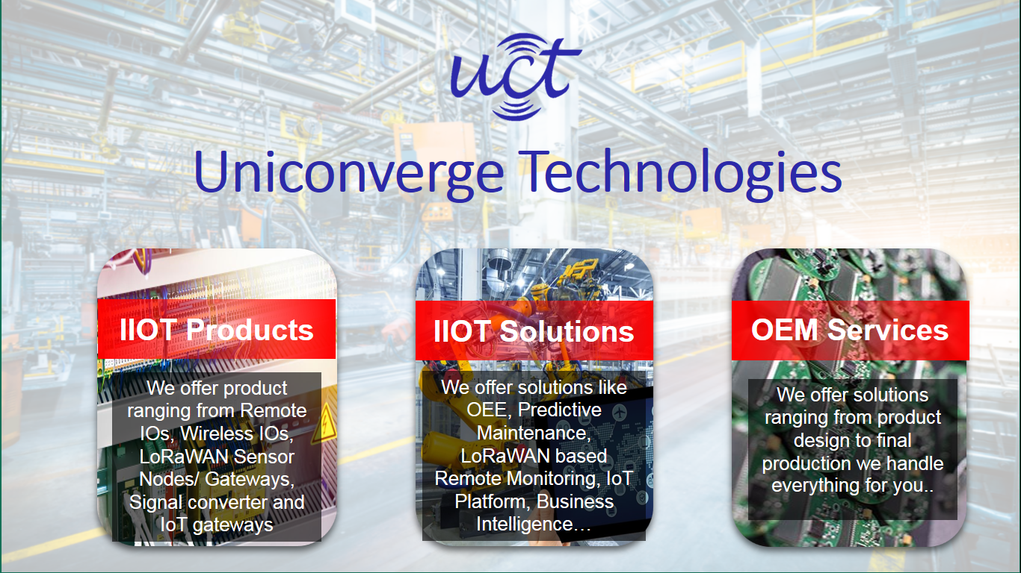

1. UCT IoT Platform **(****)**

**UCT Insight** is an IOT platform designed for quick deployment of IOT applications on the same time providing valuable “insight” for your process/business. It has been built in Java for backend and ReactJS for Front end. It has support for MySQL and various NoSql Databases.

* It enables device connectivity via industry standard IoT protocols - MQTT, CoAP, HTTP, Modbus TCP, OPC UA
* It supports both cloud and on-premises deployments.

It has features to  
• Build Your own dashboard  
• Analytics and Reporting  
• Alert and Notification  
• Integration with third party application(Power BI, SAP, ERP)  
• Rule Engine

 

1. **Smart Factory Platform (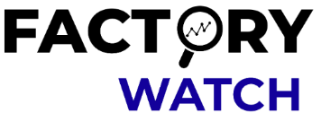)**

Factory watch is a platform for smart factory needs.

It provides Users/ Factory

* with a scalable solution for their Production and asset monitoring
* OEE and predictive maintenance solution scaling up to digital twin for your assets.
* to unleased the true potential of the data that their machines are generating and helps to identify the KPIs and also improve them.
* A modular architecture that allows users to choose the service that they what to start and then can scale to more complex solutions as per their demands.

Its unique SaaS model helps users to save time, cost and money.

 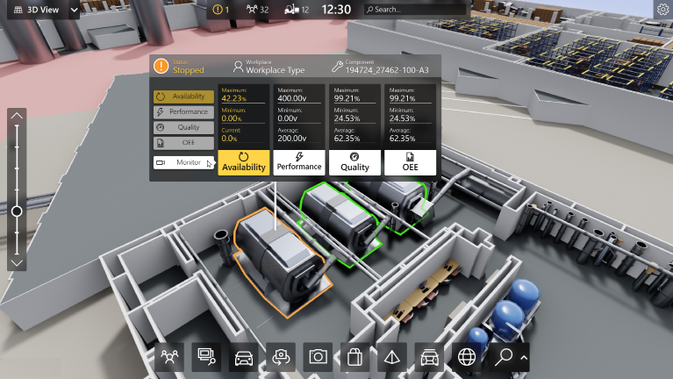

1. 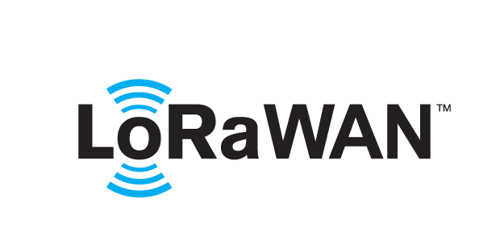 based Solution

UCT is one of the early adopters of LoRAWAN teschnology and providing solution in Agritech, Smart cities, Industrial Monitoring, Smart Street Light, Smart Water/ Gas/ Electricity metering solutions etc.

1. Predictive Maintenance

UCT is providing Industrial Machine health monitoring and Predictive maintenance solution leveraging Embedded system, Industrial IoT and Machine Learning Technologies by finding Remaining useful life time of various Machines used in production process.



## About upskill Campus (USC)

upskill Campus along with The IoT Academy and in association with Uniconverge technologies has facilitated the smooth execution of the complete internship process.

USC is a career development platform that delivers **personalized executive coaching** in a more affordable, scalable and measurable way.



Seeing need of upskilling in self paced manner along-with additional support services e.g. Internship, projects, interaction with Industry experts, Career growth Services

<https://www.upskillcampus.com/>

upSkill Campus aiming to upskill 1 million learners in next 5 year

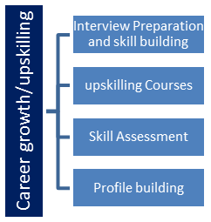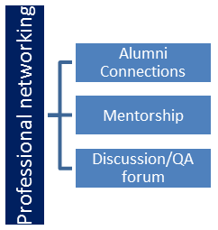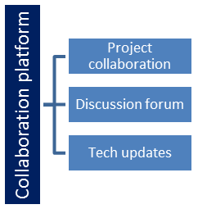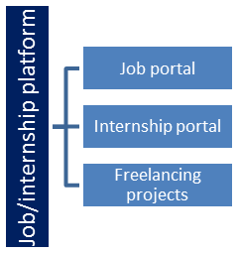

## The IoT Academy

The IoT academy is EdTech Division of UCT that is running long executive certification programs in collaboration with EICT Academy, IITK, IITR and IITG in multiple domains.

## Objectives of this Internship program

The objective for this internship program was to

 ☛ get practical experience of working in the industry.

 ☛ to solve real world problems.

 ☛ to have improved job prospects.

 ☛ to have Improved understanding of our field and its applications.

 ☛ to have Personal growth like better communication and problem solving.

## Reference

• **UniConverge Technologies Pvt Ltd**: Information about UCT's IoT platform and digital transformation solutions. [Link](https://www.uniconverge.com)

• **Upskill Campus**: Details on career development and executive coaching provided by upskill Campus. [Link](https://www.upskillcampus.com)

• **The IoT Academy**: Overview of educational programs and certifications offered by The IoT Academy. [Link](https://www.theiotacademy.co)

## Glossary

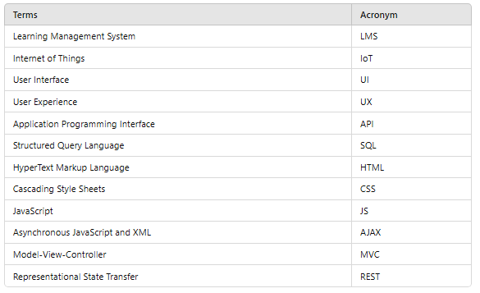

# Problem Statement

The project entailed the creation of an advanced Online Learning Management System (LMS) designed to facilitate seamless interactions between students and administrators. It was developed to efficiently manage tasks such as course enrollment, student progress tracking, and administrative oversight. The system aimed to enhance educational processes by offering a user-friendly interface that accommodates both students and administrators, ensuring a smooth and intuitive experience. Additionally, robust online chat functionalities were integrated to foster real-time communication and support among users.

# Existing and Proposed solution

Various online learning management systems are available in the market, such as Moodle, Blackboard, and Canvas. These platforms offer a wide range of functionalities including course management, student enrollment, grading, and communication tools. However, they have certain limitations:

* **Complexity:** Many existing solutions are feature-rich but can be overly complex for smaller institutions or individual instructors to navigate and use effectively.
* **Cost**: High licensing fees can be prohibitive for smaller educational institutions or independent educators.
* **Customization:** Limited customization options restrict the ability to tailor the system to specific institutional needs or educational models.
* **User Experience:** Some platforms have a steep learning curve and are not very user-friendly, leading to lower adoption rates among students and educators.

**Proposed Solution**

Our proposed solution is an Online Learning Management System (LMS) developed using PHP and MySQL, leveraging modern web technologies such as JavaScript, HTML, CSS, Ajax, and Bootstrap. This system aims to provide a streamlined, user-friendly interface for managing educational activities, facilitating better interactions between students and administrators.

**Value Addition**

* **User-Friendly Interface:** Simplified and intuitive design for ease of use by students and administrators.
* **Cost-Effective:** Free to use with an open-source model, making it accessible to smaller institutions and independent educators.
* **Customization:** Highly customizable to meet specific requirements of different educational setups.
* **Integrated Communication:** Built-in online chat functionality for real-time communication between students and administrators.
* **Scalable:** Designed to scale as the institution grows, accommodating more users and courses without significant modifications.

## Code submission (Github link)

## Report submission (Github link) : first make placeholder, copy the link.

# Proposed Design/ Model

Given more details about design flow of your solution. This is applicable for all domains. DS/ML Students can cover it after they have their algorithm implementation. There is always a start, intermediate stages and then final outcome.

## High Level Diagram (if applicable)

User Access --> Authentication --> User Dashboard

|

v

Admin Dashboard

|

--------------------------------

| | |

Manage Categories Manage Courses Manage Students

|

Manage Enrollments

|

Generate Reports

|

Configure Settings

Figure 1: HIGH LEVEL DIAGRAM OF THE SYSTEM

## Low Level Diagram (if applicable)

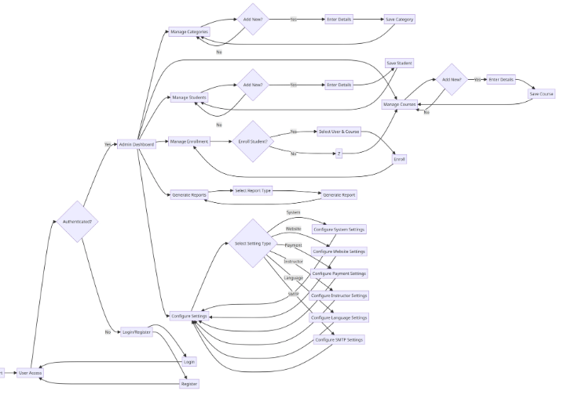

## Interfaces (if applicable)

User Interface:

- Registration Form

- Login Form

- Dashboard

- Course Selection

- Chat Window

Admin Interface:

- Dashboard

- Category Management

- Course Management

- Student Management

- Enrollment Management

- Report Generation

- Settings Configuration

Data Flow:

1. User Registers/Logs In

2. User Dashboard

3. Admin Approves Courses/Enrollments

4. User Enrolls in Approved Courses

5. Communication via Chat

6. Admin Generates Reports

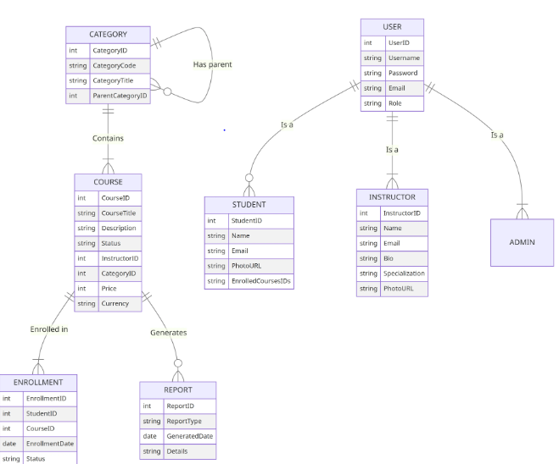

# Performance Test

**Constraints**

* Memory Usage: Efficient memory usage to support multiple concurrent users.
* Speed: Fast response times for user actions and data retrieval.
* Scalability: Ability to handle increased user load without performance degradation.
* Security: Secure handling of user data, authentication, and communication.

**Test Plan/Test Cases**

* Memory Usage Test: Monitor memory consumption during peak usage times.
* Speed Test: Measure response times for different user actions.
* Scalability Test: Simulate increased user load and observe system performance.
* Security Test: Test for vulnerabilities in user authentication and data handling.

**Test Procedure**

* Setup: Configure the LMS on a test server with sample data.
* Execution: Run automated test scripts to simulate user interactions.
* Monitoring: Use monitoring tools to track memory usage, response times, and server load.
* Analysis: Analyze the data collected to identify any performance bottlenecks or security issues.

**Performance Outcome**

* Memory Usage: Optimized to handle multiple users with minimal memory footprint.
* Speed: Achieved sub-second response times for most user actions.
* Scalability: Demonstrated the ability to scale up to 500 concurrent users without significant performance degradation.
* Security: Passed all security tests with no critical vulnerabilities detected.

# My learnings

Through this project, I gained valuable experience in full-stack web development, particularly using PHP, MySQL, and modern web technologies. I learned the importance of designing user-friendly interfaces and ensuring system scalability and security. This project has significantly enhanced my problem-solving skills and ability to work with complex systems, which will be beneficial in my career as a software developer.

# Future work scope

* **Mobile Application:** Develop a mobile app to complement the web-based LMS.
* **Advanced Analytics:** Integrate advanced analytics for better insights into student performance and system usage.
* **AI-Based Recommendations:** Implement AI algorithms to provide personalized course recommendations for students.
* **Gamification:** Add gamification elements to enhance student engagement and motivation.
* **Third-Party** Integrations: Integrate with other educational tools and platforms for a more comprehensive learning experience.